Data Analytics Dashboard
Problem Statement -: There is large amount of data Businesses have but there is no way to easily understand the data. To find out valuable insights it is hard to go through all the data. Businesses need a better insights from data and understand the data. So they need dashboard having insights about Sales, Customer interest, Trends about Region etc.

Objective -: To Visualize Sales Data in Power BI. Making Interactive Dashboard. to analyze Sales, Product performance, to identify distribution by Region, total Sales, total Quantity Sold, etc. for better decision making

Purpose / Client requirements - :
- Monitor overall sales performance
- Analyze monthly Sales
- Track product wise sales
- Tracking Total Quantity Sold, Total Sales
- Visualizing Sales Distribution by Region
- Filter and analyze data by region
- Access detailed sales records through a tabular view

Dashboard-:
1. Monthly profit trends (Line chart)
How to create:
- Select Column Chart icon on Visualization pane
- Select Month from Date and Sales Amount
- Use Gridlines for better understanding
How to Use:
Track monthly profit trends includes:
- Sales by Month
- Visualize Performance by Month

2. KPI Cards displaying Total Sales Amount, Total Amount, Total Quantity Sold
How to create:
- Select Card icon on Visualization pane
- Select all the fields want to show
- Format Cards using options in Callout
How to use:
These Cards display Key Performance Insights here showing:
- Total Sales
- Total Amount
- Total Quantity Sold

3. Detailed Data View (Table)
How to create:
- Select Table icon on Visualization pane
- Select All Fields
- Format Visuals for Better Understanding
How to Use:
Track Data in Table Shows:
- View Detailed Data Overview

4. Sale by Region (Donut chart)
How to create:
- Select Donut Chart icon on Visualization pane
- Select Region and Sales Amount
- Change Detail labels to Category, percentage
- Turn off legend for better visual
How to Use:
Track Sales by Region Shows:
- Top Region
- View Total Sales in Region by hovering
- Sales contribution by each Region

5. Region Slicer
How to create:
- Select Slicer icon on Visualization pane
- Select Region Field
- Change Style accordingly
How to Use:
Allows to Filter entire Dashboard Shows:
- Region Wise Performance

6. Product Filter
How to create:
- Select Slicer icon on Visualization pane
- Select Product Field
- Use Drop Down type from slicer settings
How to Use:
Allows to Filter entire Dashboard Shows:
- Region Wise Performance

Solved Problems -:
- Converted raw sales data into an easy to understand visual format
- Identified Sales Distribution by Month, Region and Product
- Identified Top performing Products, Regions and Months
- Created Table View for Detailed Understanding of Data
- Reduced manual effort required for analyzing large sales datasets.

Conclusion -: The Data Analytics Dashboard successfully transforms raw sales data into useful business insights. User can monitor Sales performance, Product trends, and regional sales distribution. The dashboard helps businesses make better decisions and identify growth opportunity through data analysis.

Dashboard Photos -: 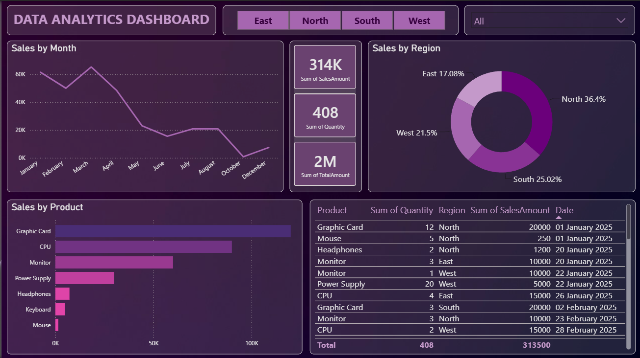

Name -: Prathmesh D. Tamboli

